

Architectural and engineering specifications

JK18WA1
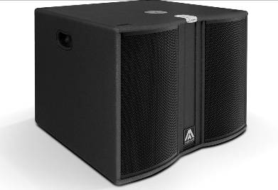
• The subwoofer loudspeaker system shall have one ferrite magnet 18-inch low frequency transducer loaded in a band-pass tuned enclosure. It shall be rated at a nominal impedance of 8 ohms.

• The usable bandwidth shall be 32Hz to 110Hz (-10dB).

• Maximum SPL continuous, measured at 1m under free field conditions shall be 128dB.

• Enclosure shall be band-pass type with some lateral rectangular ducts.

• Enclosure cabinet construction shall consist of birch plywood with a black textured finish. Dimensions shall be 740 mm (29,1 inch) wide, 552 mm (21,7 inch) high, 710 mm (27,9 inch) deep. Enclosure weight shall be 50,9 Kg.

• The front enclosure shall be protected by two steel grilles with acoustically transparent foam. The grilles shall be secured via screws to keep it in place when facing the cabinet downwards.

• The cabinet shall feature a round socket with M20 thread located on the top panel to allow full-range enclosure coupling.

• The amplifier shall be built inside the cabinet, consisting of two bridged channels, with a total power of 1000W/8Ohm. The amplifier shall be 3rd Generation Class D with switching power supply. The amplifier’s power supply shall automatically select the input voltage.

• The audio input shall be electronically balanced with a 20kOhm impedance. Connectors shall be XLR type (one female for input and one male for linking). Mains supply shall be through PowerCon.

• The DSP controller shall be built inside the cabinet and integrated to the power amplifier. The internal DSP architecture shall be 48-bit fixed point, featuring 2nd order IIR biquad filters. Analog-to-Digital converters shall have more than 102dB signal-to-noise ratio, 24-bit word size and shall work at 48kHz sampling rate. The controller shall contain several factory presets that shall be visible and selectable by the user at the cabinet’s rear panel (with built-in LCD and keypad). The gain shall also be adjustable from the keypad. The DSP shall incorporate a up to 40-meter (118ms) delay line and a polarity inversion control (0º -180º).

• The system shall be capable of monitoring the following parameters: input level, output level, output stage temperature (in the LCD), clip limiter activation and amplifier protection status (with LEDs).

• The amplifier shall be capable of switching itself automatically on a low power consumption mode, depending on the presence of audio signal at the input. The low power consumption mode shall be user selected and the power consumption under this circumstance shall not exceed 5 Watt. The amplifier shall be able to reactivate itself to normal operation after detecting audio signal at its input.

• The loudspeaker system shall be the Master Audio® Joker JK18WA1.

